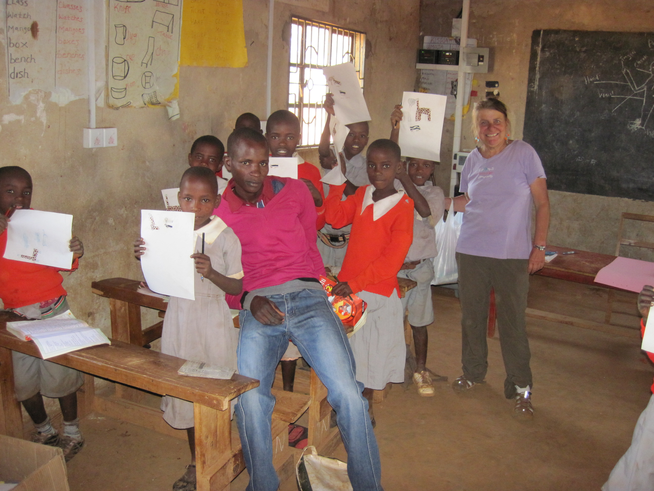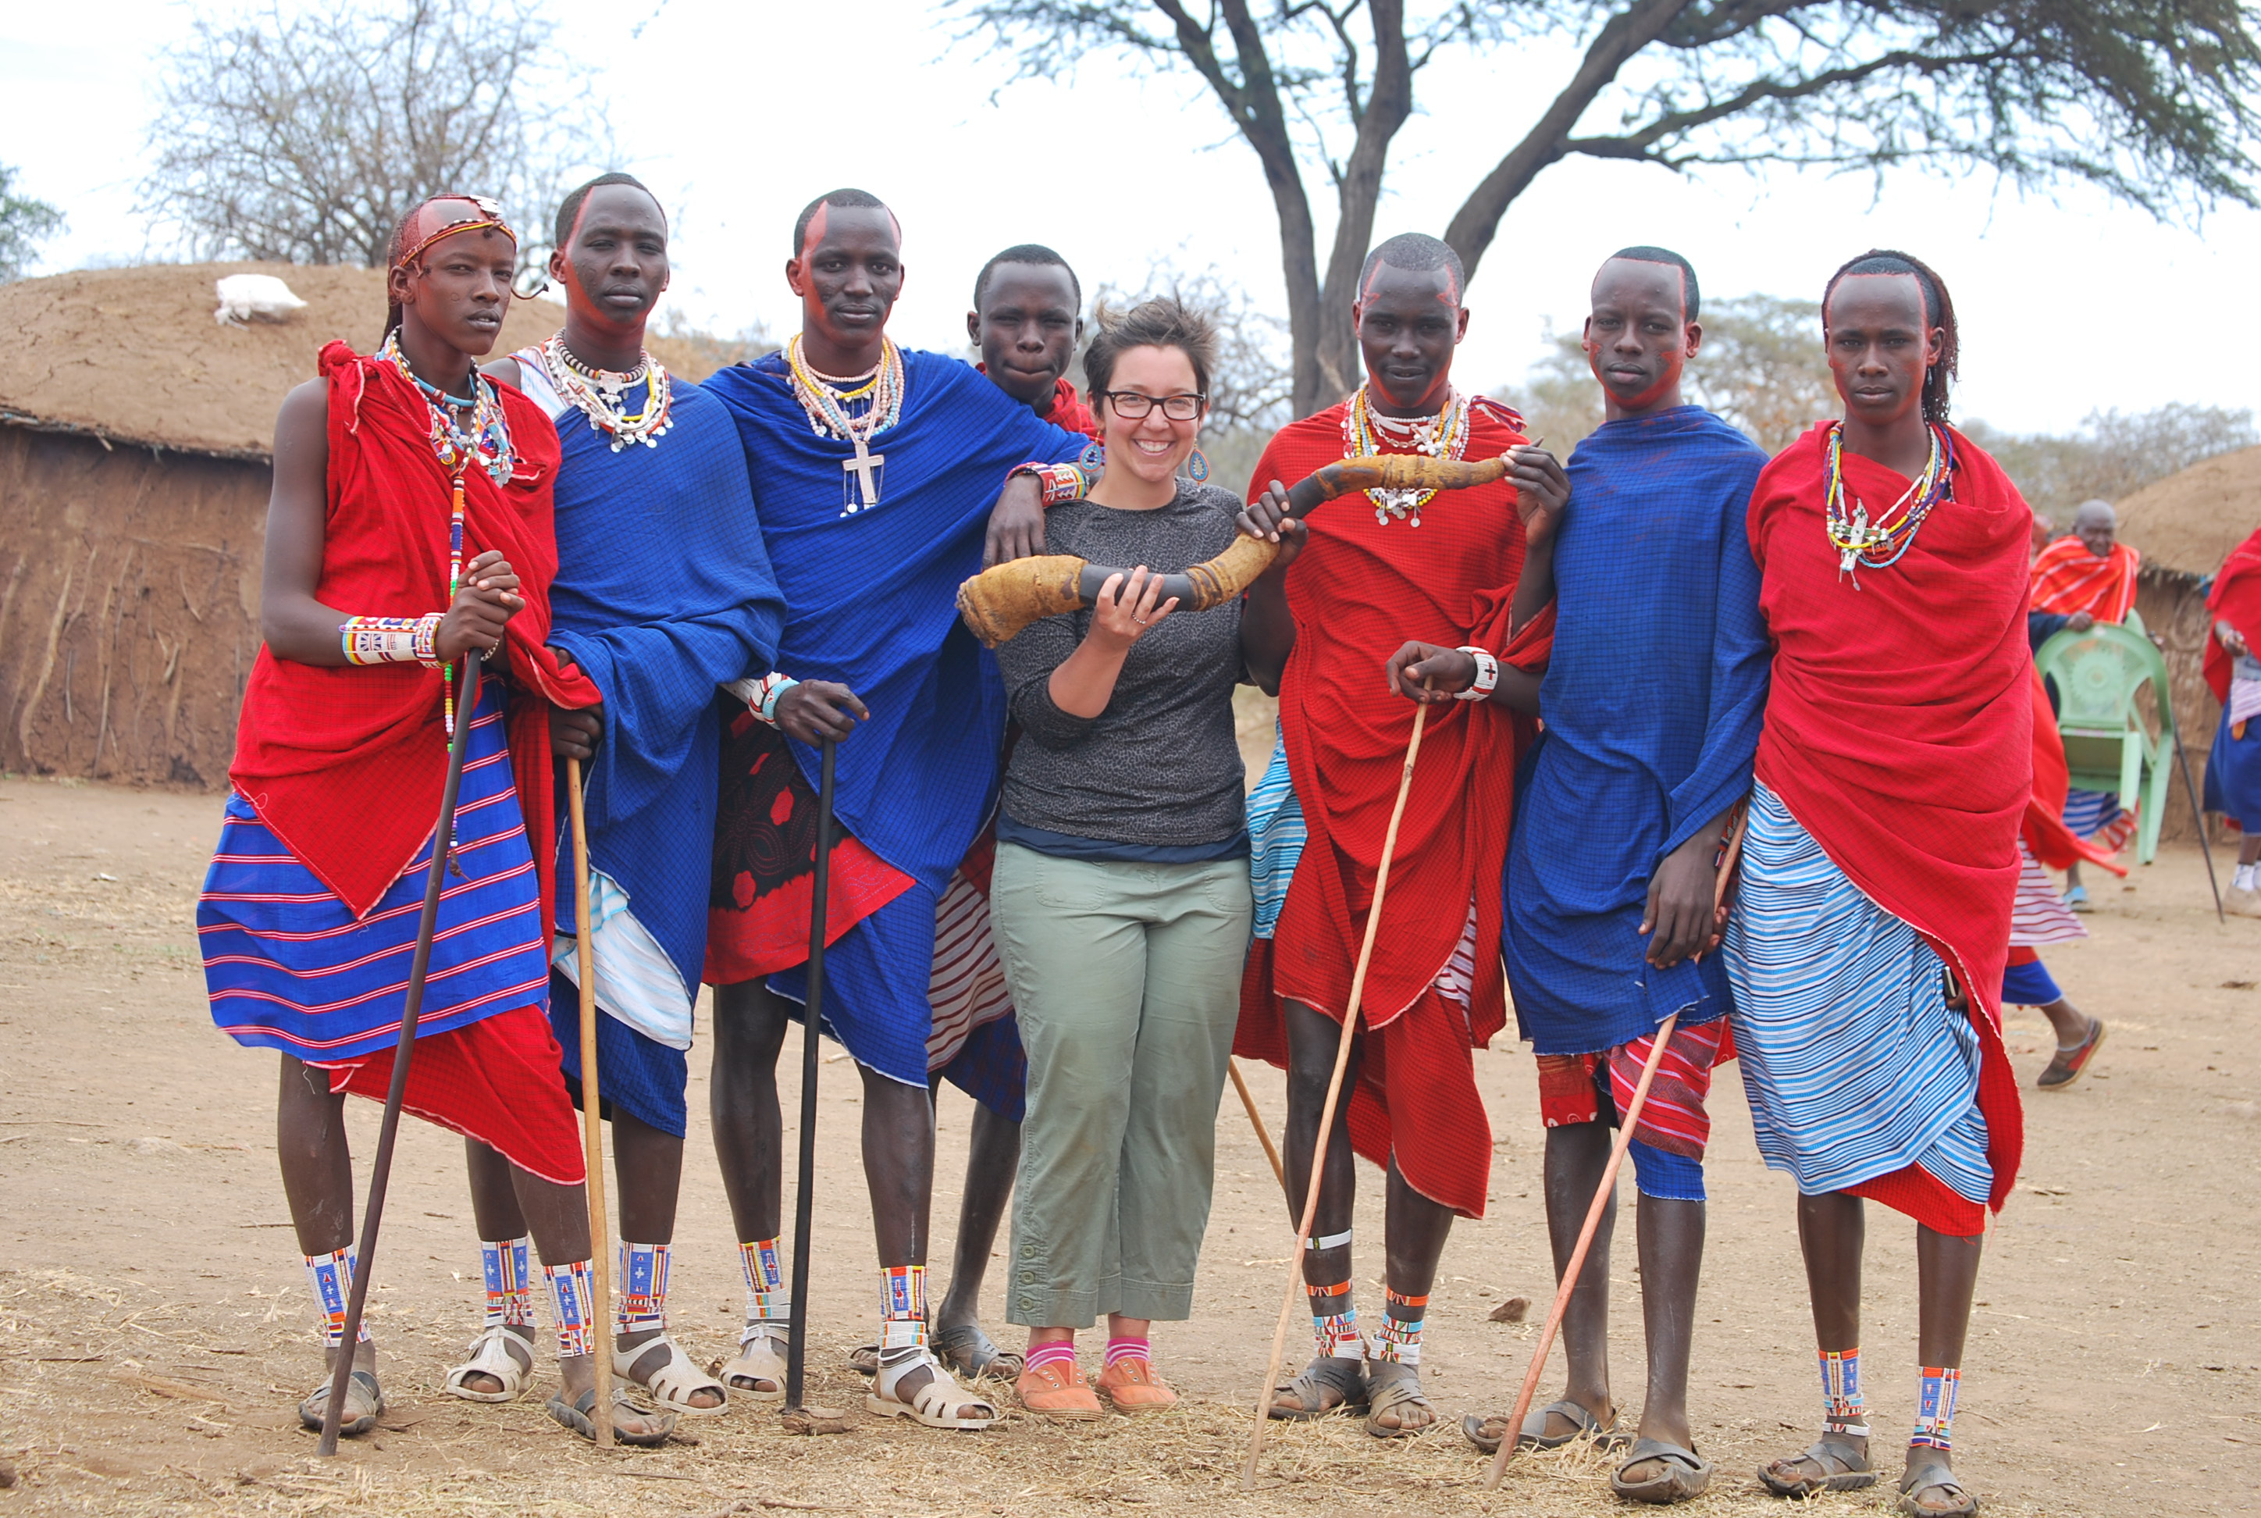  VOLUNTOURISM  Exciting news!!!! The Project is in the process of developing a voluntourism program. Visitors to Lemong’o will stay within the village, engage in meaningful volunteer opportunities, and be immersed in traditional Maasai culture and activities. Proceeds from this program will provide employment and fund teachers’ salaries and the school lunch program. Email if you are interested in participating. | The Lemong’o Project is a charitable non-profit organization dedicated to empowering the Maasai people of Lemong’o in rural Kenya through improvement of nutrition, access to education, health support, and employment opportunities.  thelemongoproject.org  thelemongoproject@gmail.com  Instagram/ thelemongoproject  Twitter/@thelemongoproject  FB/thelemongoproject  THE LEMONG’O PROJECT  7314 Linden Drive  Anchorage, AK 99502 | THE LEMONG’O PROJECT
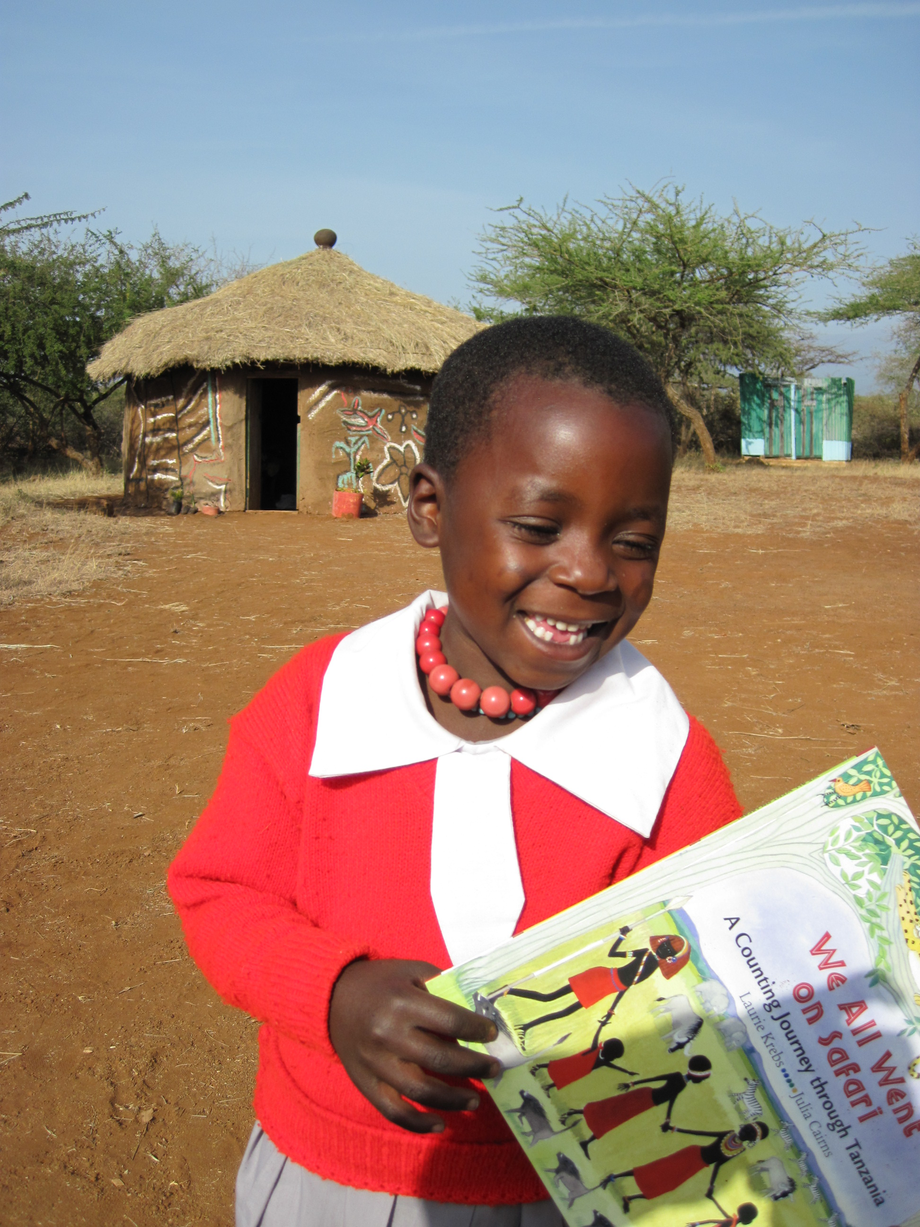  EDUCATON  Education is highly valued in Lemong’o. Children walk long distances to attend school each day. Education is viewed as a privilege. Parents and children are very grateful for the opportunity.  The Project pays the salaries for 3 of the village teachers. Tuition is used to pay for 3 additional teachers. Due to parents’ lack of funds, teachers are often paid late or are not paid in full. The Project would like to provide additional support for teacher salaries so that all teachers receive full salaries. | 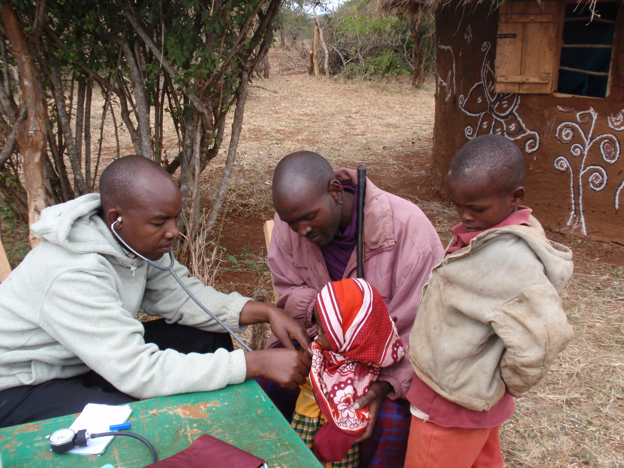  MEDICAL SUPPORT  Each summer The Project provides free medical clinics. Two local doctors and a nurse administer medical care and medication within the village. This allows villagers to receive medical care without having to walk long distances or pay for transportation. Transport costs are often a barrier to medical care. Vision screenings are performed; eye glasses are provided courtesy of Lions Club 49A/B Alaska. | 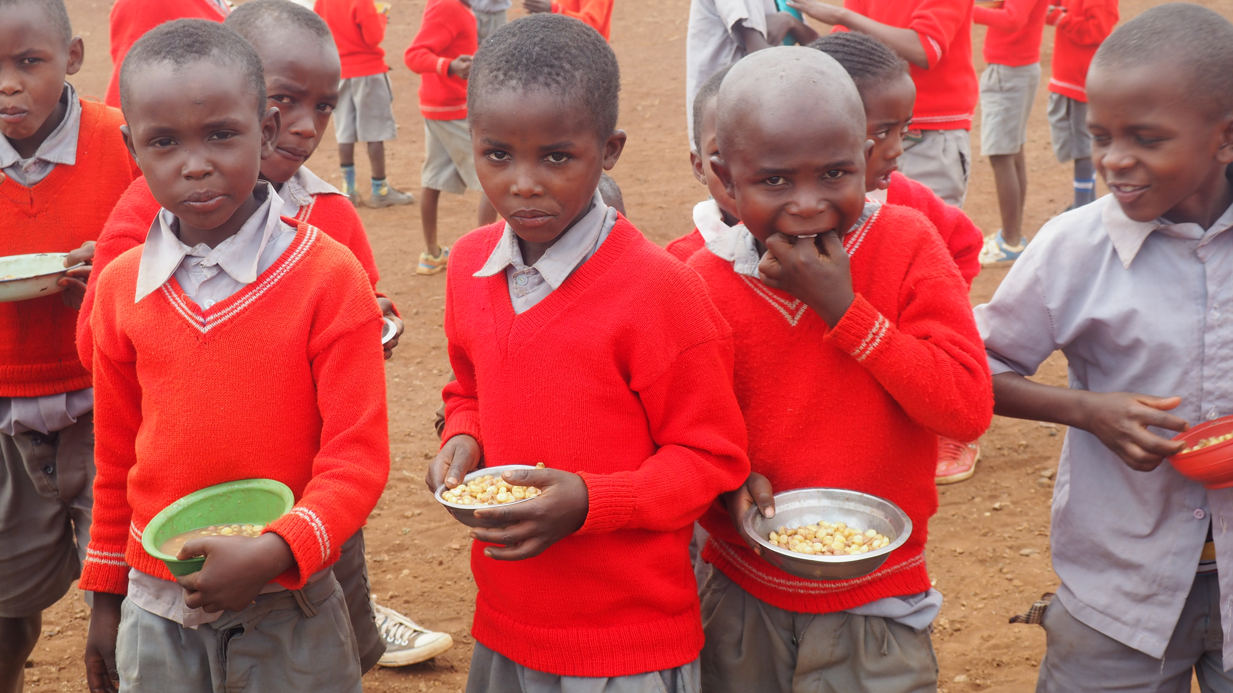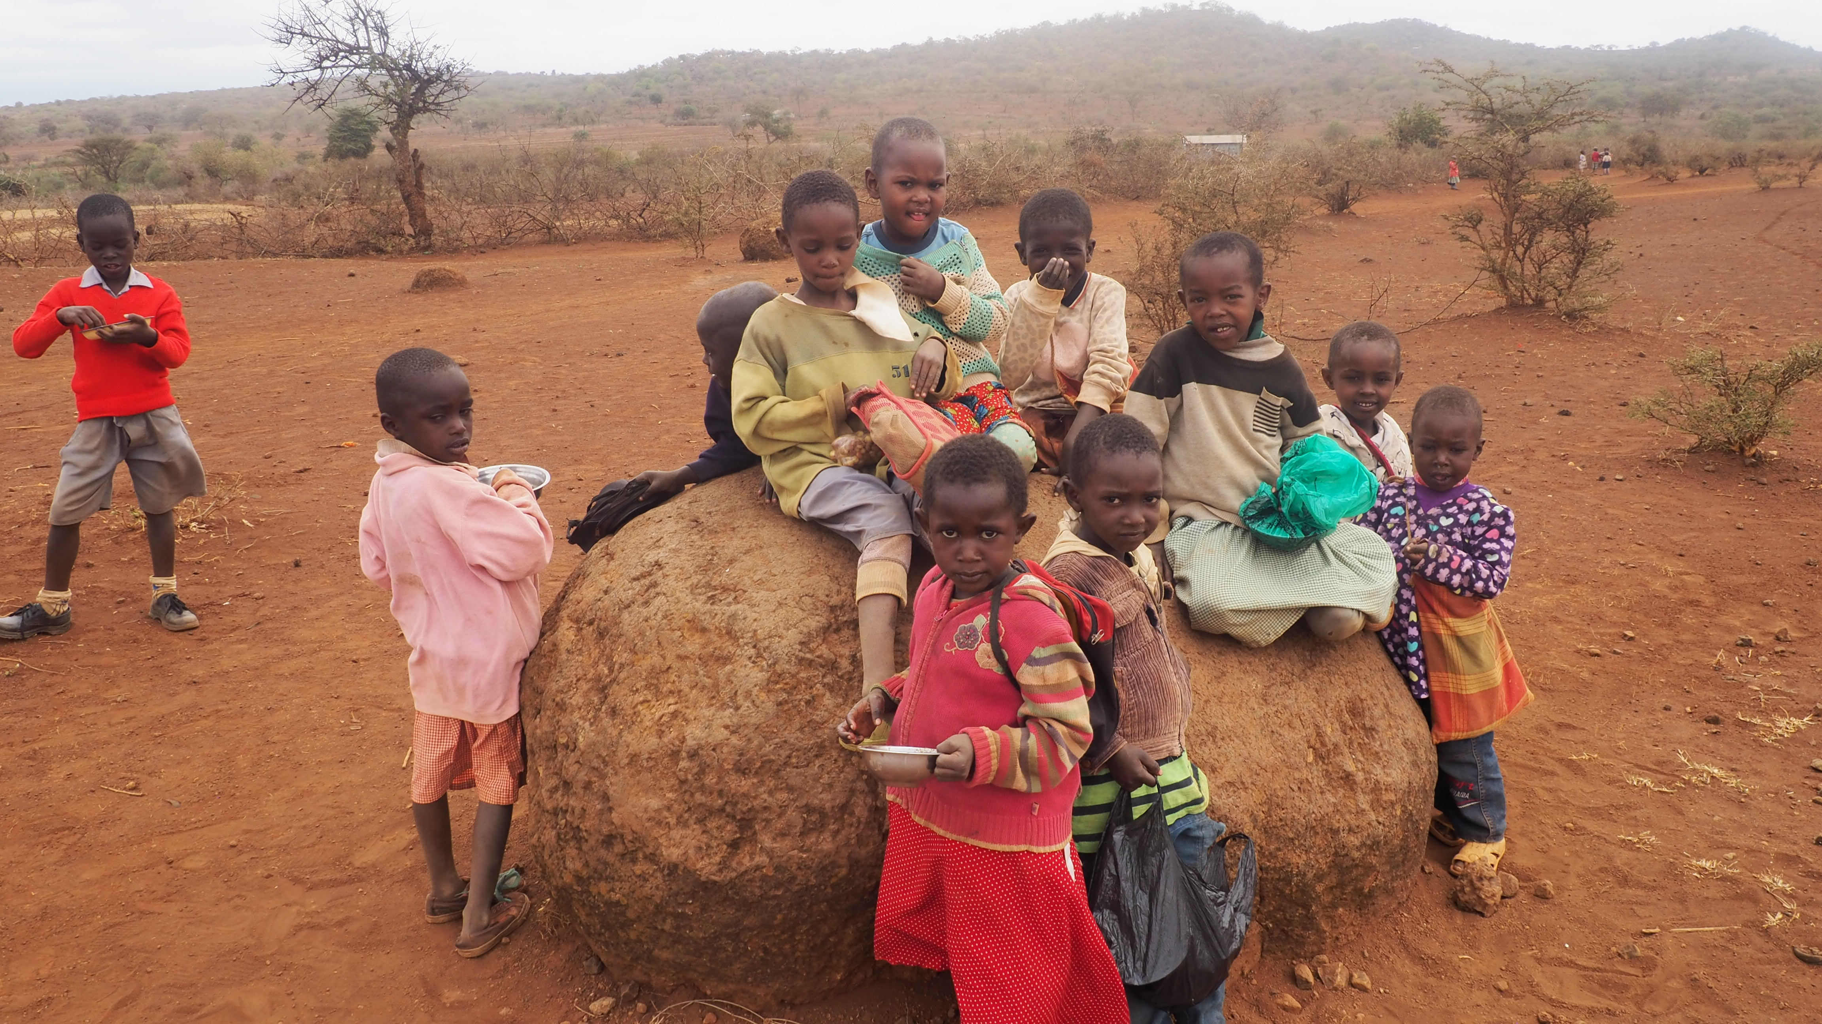  NUTRITION  The Lemong’o Project provides free school lunch to 500 students each day. For many of these students, this is their only nutritious meal of the day. When The Project began providing lunch, school enrollment increased from 225 to over 500. The Project would like to expand our nutritional program to include breakfast. Receiving proper daily nutrition is crucial to academic success.

