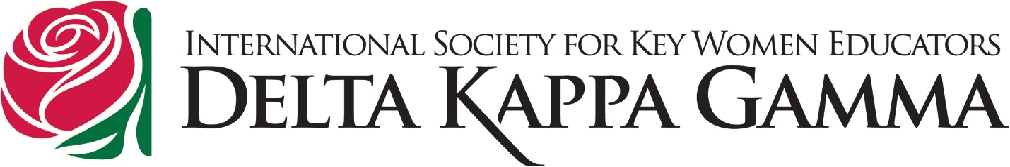
State Organization, Alaska
October 18, 2022
To: all DKG Members
From: The Nominating Committee, 2021 – 2022

At our Spring Meeting in 2023, we will be electing new officers for the 2023 – 2025 biennium as follows:
President
First Vice President
Second Vice President
Secretary
Nominating Committee – 3 members, one from each of the areas of the state.

Please contact anyone the present committee with recommendations.
Geri Benshoof
phone 907 378-2244
Email geribenshoof@aol.com
Gayle Hammons
Phone 907 738-2701
Gretchen Van Hove
Email gvhmlk@alaska.net

