Sarajustine Black
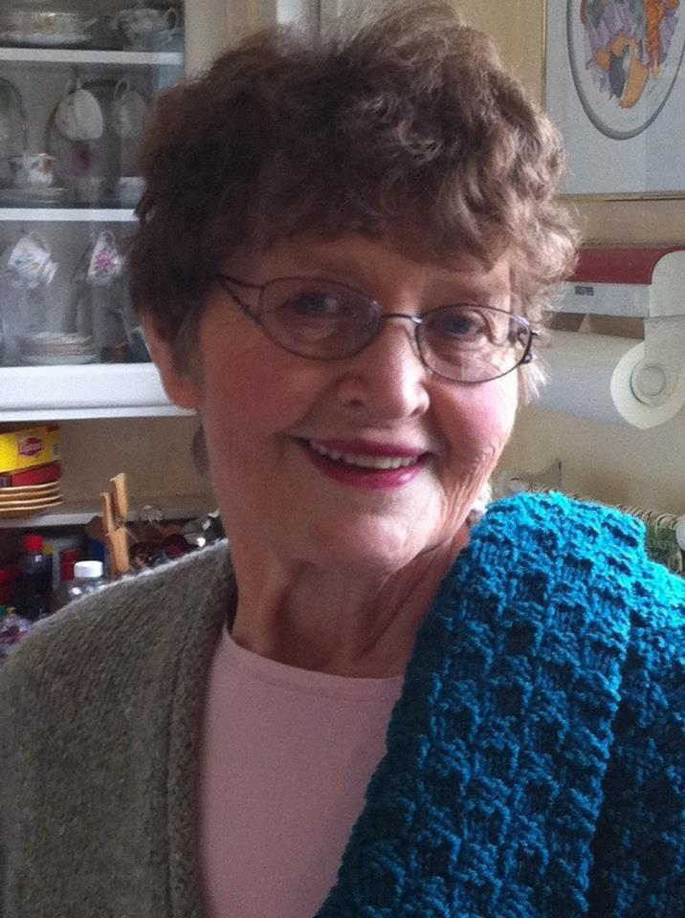
Sarajustine came to Ketchikan in 1969 as a fairly new teacher and team-taught special education at White Cliff School. Kappa Gamma Epsilon Chapter invited new teachers to a “get-acquainted” event. SJ was interested in the group but found out an invitation was needed to join. It was not until 1976 that she was finally invited to join DKG. Sarajustine was involved for twenty-eight years in this organization and it was one of her favorites. She had come from Hope, and previously had taught in an Alaskan Eskimo village straight from New Jersey. While she taught at White Cliff she was involved with all facets of KEA:as a representative, relations chair, Secretary, and PACE chair. After her retirement in 1984, she was on the local school board and continued to keep busy with annual NEA trips as a delegate. Sarajustine relayed that her total professional involvement had really been enhanced by her participation in the local and State Beta chapters.

Sarajustine had also been very active in the Ketchikan community. She volunteered at St. John’s Episcopal Church with fundraisers and helped to run their homeless soup kitchen, spent 20 years at the community theatre- First City Players, was secretary of the Arts Council and also served as a disc jockey at the local radio station, KRBD for over 30 years. She was a Hospice Volunteer and helped to keep the local group thriving, also for about 30 years. Nome and the Iditarod seemed to pull her heart and she was a regular volunteer in Nome and really looked forward to her time helping out the teams. Sarajustine had a huge heart and helped many young people as well as homeless folks by either providing them with wonderful home cooked meals and baked goods or by employing them to do yard work and errands for her. She seemed to have a special place in her heart for those she considered down-trodden or needing a little extra care. Sarajustine was also known for her love of parties and times when friends could get together; she would pull out home-made baked and her china teacups and visit at the drop of a hat. She had great joy in doing outdoor activities such as gardening, boating out to a remote cabin and going fishing with her friends. There were not many things that Sarajustine would not try – she believed life is good and should be lived to the fullest. She was also a very caring person and is missed by the many people whose lives she touched.

From Christine Klein:

Some may not know, but Sarajustine was also a treasured only-daughter, former nun, and, a mother. For a number of years after arriving in Ketchikan she provided full time care to her mother Mary who had quickly declined in health. Later she became a full time adopted-surrogate mother to three high-school students. She was instrumental raising and guiding them through 'trying teen' years while they attended Ketchikan high school from remote areas without schools. Today all are accomplished professional, active, contributing members of their communities in Alaska with families of their own: David King is in Fairbanks originally from Hobart Bay; Christine Klein is in Anchorage from Moser Bay/Loring; and Chere Klein-Enright is in Ketchikan from Moser Bay. Sarajustine remained an active family member in all major milestones of their lives and families throughout her life, and she was very proud of them.

Sarajustine was the most active community member, volunteer, woman professional, political activist, and teacher I've ever met or been mentored by. She sometimes really didn't realize how positively she impacted thousands of youth and people throughout her life. When they'd stop by, call up, reach out, or remember her decades later - she was always so tickled and pleased. In the two weeks before she asked to return to heaven, I read aloud to her all the messages coming in (she particularly loved the message/song from you Delta Kappas!) and those on facebook, email, twitter and other e-age accounts -- she was truly amazed, wonderous and thankful at how many former students and friends were sending along memories, care, and love. It made her so happy and she'd give that BIG, HAPPY, snuggly WARM SMILE.

Thank you!
Christine Klein

